Anaerobic Digestion
Project Management Plan

Date | 31/05/2025
Author | Manav Nursmooloo  Krishna Gulati  Amal Kapadia  Syed Saad  Ali Imran
Version | 0.3

Project Management Plan (PMP)
Project Details
Project Name |  | Project Phase | POL Number
EcoGen Solutions - ANAEROBIC DIGESTION
Project Manager
Project Manager Name
Approver | Name |  | Approval Date

List of Reviewers
Reviewer | Role | Endorsement Date

Version History
Version |  | Date | Comments
V0.1 | Project Introduction & Project Definition | 12/04/2025 | Completed full initial draft of the project plan. Developed a clear project background outlining the environmental and energy challenges faced by small to medium-sized pig farms in Australia. Defined SMART objectives targeting methane emissions reduction, energy offset through biogas generation, and revenue from digestate sales. Detailed the project scope, specifying what is in and out of scope. Documented key assumptions and constraints.
V0.2 | Executive Summary  Amended Project Introduction & Project Definition  Project Management Deliverables  Project Plan  Project Governance  Project Budget  Project Management Controls | 12/05/2025 | Refined the project scope and confirmed feasibility assumptions. Established a detailed stakeholder list and classified each using a Power-Interest Grid. Finalised SMART objectives and developed a RACI matrix aligning responsibilities with deliverables. Introduced the hierarchical decision-making model and updated project phases and stage descriptions to align with the waterfall methodology. Developed the draft Gantt chart, incorporating all key milestones and deliverables, including digestate storage and regulatory approvals.
V0.3 | Executive Summary  Project Introduction & Project Definition  Project Management Deliverables  Project Plan (Including Definition on Ready & Done)  Project Governance  Project Budget  Project Management Controls (Including Quality Management) | 30/05/2025 | Amended V0.2 as per feedback received. Finalised the PMP by completing:  5.4. Definition Ready & Done  5.5. Deployment  8.2. Quality Management

Contents
1. Executive Summary 6
2. Introduction 6
2.1. Project Background 6
2.2. Project Objectives 7
3. Project Definition 7
3.1. Project Scope 7
3.2. Assumptions 8
3.3. Constraints 9
4. Project Management Deliverables 10
4.1. Overview 10
4.2. Roles and Responsibilities 11
4.3. Deliverable Descriptions 12
5. Project Plan 13
5.1. Project Schedule and Delivery 13
5.2. Stage Descriptions 14
5.3. Build Cycles 15
5.4. Definition of Ready and Done 16
5.5. Deployment 17
6. Project Governance 18
6.1. Project Team 18
6.2. Decision Management 20
7. Project Budget 21
7.1. Summary 21
7.2. Cost Assumptions 21
8. Project Management Controls 22
8.1. Risk Management 22
8.2. Quality Management 23
8.3. Project Tools 25

Glossary
Abbreviation | Term | Description
IPCC | Intergovernmental Panel on Climate Change | A UN body that assesses the science related to climate change.
LPG | Liquefied Petroleum Gas | A flammable fuel used for heating, cooking, and sometimes power generation.
EPA | Environment Protection Authority | A government agency that enforces environmental laws and regulations.
O&M Manual | Operation and Maintenance Manual | A document detailing procedures for operating and maintaining a system safely.
CH₄ | Methane | A primary component of biogas and a potent greenhouse gas, measured as a percentage of gas output.
COD | Chemical Oxygen Demand | The amount of oxygen required to chemically oxidize organic compounds in water—indicates pollution.
VS | Volatile Solids | The portion of total solids in waste that can be volatilized, representing organic content.
SEPP | State Environment Protection Policy | Victorian policies that set legally binding environmental quality standards for air, water, land.
ISO | International Organization for Standardization | Global body that publishes international standards, including those for quality management (ISO 9001).
AS/NZS | Australian/New Zealand Standard | Australian/New Zealand Standard
P&IP | Piping & Instrumentation Diagram | Detailed schematic showing the piping, valves, and instrumentation in a process system.
SOP | Standard Operating Procedure | Standard Operating Procedure
cfu/g | Colony-Forming Units per Gram | Unit measuring the number of viable microbial cells in a sample per gram, used for digestate safety.
- Executive Summary
This report presents a comprehensive project plan for the implementation of an anaerobic digestion (AD) system at a 535-sow piggery in Victoria, Australia. The aim of the project is to reduce greenhouse gas emissions, improve on-farm waste management, and generate value from biogas and digestate outputs.

The report outlines the project's purpose, scope, key stakeholders, and delivery approach. A waterfall methodology has been adopted, supported by a structured schedule, stakeholder RACI matrix, and project team hierarchy to ensure clear governance and accountability throughout each phase.

Key components include:
- A detailed budget covering labour, equipment, materials, and operational costs, with a 10% contingency allowance.
- A risk management plan that addresses both positive and negative risks at strategic, investment, and project levels.
- Defined roles and responsibilities for team members, suppliers, and advisors.
- A structured deployment plan with clear Definition of Ready (DoR) and Definition of Done (DoD) gates for dry commissioning, wet commissioning, ramp-up, and handover—linked directly into our Quality Management processes to ensure every phase meets performance and compliance standards.
- Use of appropriate tools for documentation, communication, scheduling, and risk tracking.

The project is expected to deliver both environmental and economic benefits, provided that timelines are maintained, risks are managed proactively, and knowledge transfer to farm staff is effectively completed. The report recommends early engagement with regulators, structured staff training, and ongoing performance monitoring post-commissioning to ensure long-term success.
- Introduction
  - Project Background
Australia’s piggery sector generates large volumes of manure, which, if unmanaged, decomposes anaerobically and emits methane—a greenhouse gas ~28 times more potent than CO₂ (IPCC, 2021). In intensive operations, open effluent pits and uncovered lagoons can produce up to 75% of farm-level methane emissions (Skerman & Collman, 2020), undermining climate targets and causing odour and water-quality issues.
Anaerobic digestion (AD) provides a circular solution: in sealed tanks, microbes break down manure into biogas (60–70% methane) and digestate. Biogas is combusted in combined heat and power (CHP) units to produce renewable electricity and heat, reducing reliance on grid power and LPG, while digestate—after minimal treatment—serves as a fertiliser co-product (Fluence, 2023).
A 535-sow piggery in Victoria demonstrated 53–80% methane reduction, over 100,000 kWh in annual energy output, and AUD 50,000–60,000 in energy savings (Australian Pork Ltd, 2023). By selling digestate in bulk to third-party processors, farms gain additional income—AUD 25,000–55,000—without in-house certification or marketing. For example, Kia Ora Piggery uses a 160 kW CHP system to meet on-farm energy needs through biogas (Evo Energy Technologies, 2023).
  - Project Objectives
The following SMART objectives have been defined to ensure the project delivers measurable environmental, energy, and economic benefits within its first year of operation:

-Reduce Methane Emissions:
Capture and combust manure-derived biogas to achieve a 70–80% reduction in on-farm methane emissions within 12 months of commissioning.

-Offset Farm Energy Use:
Generate ≥ 100,000 kWh/year of renewable electricity and substitute 100% of LPG for heating via CHP, with systems operating at full capacity within 3 months of start-up.

-Generate Digestate Revenue:
Sell 100% of digestate output to a third-party fertiliser processor under a pre-negotiated commercial agreement, securing ≥ AUD 25,000 in annual revenue in Year 1 of operation.

- Project Definition
  - Project Scope
This project involves the design, procurement, installation, and commissioning of an anaerobic digestion (AD) system at a 535-sow farrow-to-finish piggery in Victoria. The system will process approximately 5,000–6,000 litres of manure daily using a covered anaerobic lagoon, generating biogas for on-site electricity and heat, and producing digestate as a nutrient-rich co-product. Unlike direct-to-farm sales, the digestate will be sold in bulk to a third-party fertiliser processing company, which will handle further treatment and distribution.

This model streamlines operations for the piggery and aligns with practices used in the pork industry, where digestate is monetised without requiring in-house certification or marketing (Australian Pork Ltd, 2023). The project will comply with EPA Victoria regulations, including guidelines for the safe production and use of digestate, ensuring environmental and human health protection (EPA Victoria, 2024). It also meets sustainability lending criteria (e.g., NAB Agri Green Loan) and advances multiple UN Sustainable Development Goals.

    - Items In-Scope
-Feasibility assessment and stakeholder consultation
-Detailed engineering design of the covered anaerobic lagoon system
-Procurement and installation of:
- Anaerobic digester and biogas capture infrastructure
- Biogas-powered 50–100 kW generator
- Digestate storage and load-out facilities
-Staff training on system operation, monitoring, and safety
-Compliance with environmental regulations (EPA Victoria and local council)
-Partnership agreements with third-party digestate buyer
-System commissioning, performance monitoring, and emissions reporting

    - Items Out of Scope
-Direct sale or certification of digestate as a retail fertiliser product

-Biogas upgrading for grid injection or transport fuel

-Farm-wide energy system upgrades not related to AD

-Co-digestion with off-farm waste (considered for future expansion)

-Digestate processing (e.g. drying, pelletising, composting)

  - Assumptions
Assumption | Description and impact of the assumption
Manure Volume Consistency | Assumes the 535-sow piggery produces ~2,000 tonnes of effluent annually. Lower volumes may reduce biogas and ROI.
Effluent is Collectible and Pumpable | Assumes the existing effluent system can reliably feed the AD unit. Failures may require costly retrofits.
Regulatory Permits Approved in 3–6 Months | Assumes EPA and council approvals will follow typical timelines. Delays could impact construction and delivery.
Third-Party Digestate Buyer Honour Agreement | Buyer is expected to accept all digestate. Defaults may lead to on-farm storage and disposal issues.
Reliable Generator Operation | Biogas genset is assumed to operate at ≥90% uptime. Any drop may limit energy savings and prolong payback period.
Skilled Contractors Are Available | Assumes qualified biogas installers are available in regional Victoria. Shortages may raise costs or cause delays.
Electricity Prices Remain at or Above Current Levels | Assumes grid electricity remains ≥$0.30/kWh. Lower tariffs may weaken ROI.
Farm Staff Will Be Trained and Retained | Assumes staff will be trained and remain post-handover. Gaps could impact daily system performance.
AD Technology Supplier Installation | Assumes supplier will assist with installation as part of the contract.

  - Constraints
Constraint | Description and impact of the constraint
Fixed Herd Size | Manure output is limited by herd size, capping biogas and digestate volumes. System cannot be economically oversized.
Grid Export Not Permitted | Energy must be consumed on-site. The project can’t generate revenue from electricity sales, limiting income streams.
Construction Footprint Is Limited | Space is constrained to a defined area near existing lagoons. Digestate storage must be designed efficiently.
No Co-Digestion in Scope | The system will use only piggery effluent. No external organic waste will be added to boost gas yield or tipping fee income.
Single Buyer Digestate Model | Digestate will be sold to one third-party buyer. If the partnership fails, the farm cannot easily switch to retail fertiliser sales.
- Project Management Deliverables
  - Overview

This project will generate a number of documented and tangible deliverables aligned with each project phase. These include feasibility validation reports, design packages, permits, equipment procurement records, training modules, commissioning reports, and post-project evaluations. Each deliverable has been assigned according to a structured RACI matrix, ensuring clarity of ownership, accountability, and engagement across stakeholders.

Stakeholders have been classified using a Power-Interest Grid, ensuring those with the greatest influence (e.g., Piggery Owner, Project Manager, AD Supplier, Funding Partner) are managed closely, while operational staff and community stakeholders are kept informed and engaged at appropriate points. This ensures both delivery and buy-in, particularly as long-term operation and revenue depend on seamless commissioning and community acceptance.

The following RACI matrix outlines the assignment of responsibility, accountability, consultation, and information flow across all major project deliverables.

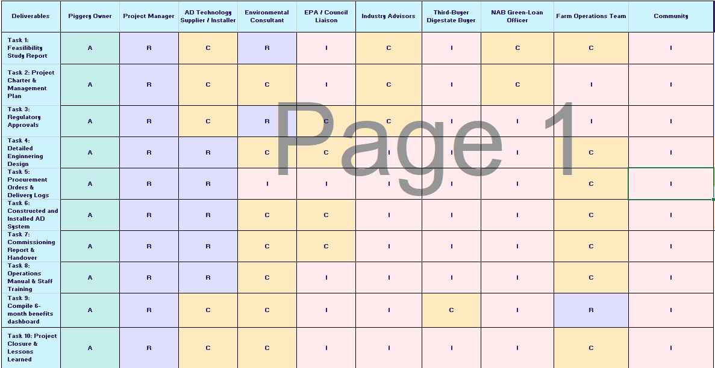

  - Roles and Responsibilities
To ensure effective stakeholder engagement throughout the anaerobic digestion (AD) system implementation, stakeholders have been classified using a Power–Interest Grid as follows:
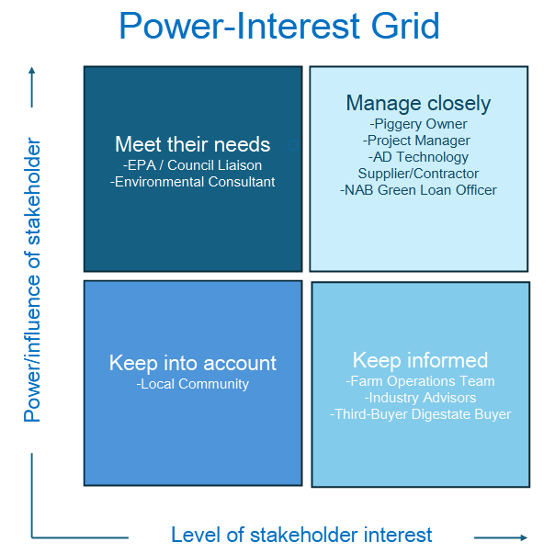

Manage Closely (High Power, High Interest)
Engage actively; these stakeholders are critical to project delivery and success.
- Piggery Owner (Sponsor): Provides funding, sets strategic goals, and approves key decisions.
- Project Manager: Oversees planning, coordination, and execution across all phases.
- AD Technology Supplier/Contractor: Supplies and installs the core AD system; responsible for system performance.
- NAB Green Loan Officer: Monitors project compliance and disburses funding in line with milestones.
Meet Their Needs (High Power, Low Interest)
Ensure their requirements are met to avoid delays or non-compliance.
- EPA / Council Liaison: Issues permits and ensures environmental/legal compliance.
- Environmental Consultant: Supports permitting by aligning technical design with regulatory standards.

Keep Informed (Low Power, High Interest)
Keep updated regularly; their engagement ensures long-term operational success.
- Farm Operations Team: Will operate and maintain the AD system post-handover; requires training and support.
- Third-Party Digestate Buyer: Purchases 100% of digestate output; essential for revenue flow and logistics.
- Industry Advisors: Provide sector guidance and validate best practices.
Keep into Account (Low Power, Low Interest)
Monitor and inform as needed to maintain public support.
- Local Community: May raise concerns around odour, traffic, or safety; early communication builds trust.

  - Deliverable Descriptions
Deliverable | Description | Responsible
Feasibility Study Report | Evaluates site viability, biogas potential, return on investment, emissions reduction, and regulatory feasibility. | Project Manager + Environmental Consultant
Project Charter & Management Plan | Defines project scope, objectives, governance, stakeholder roles, and communication protocols. | Project Manager
Regulatory Approvals | Secures necessary EPA and council permits covering environmental, safety, and zoning compliance. | Project Manager + Environmental Consultant
Engineering Design Package | Delivers detailed technical drawings and specifications for the AD system, generator, and digestate storage. | Project Manager + AD Supplier
Procurement Records | Includes purchase orders, supplier contracts, and delivery logs for all critical system components. | Project Manager + AD Supplier
Constructed AD System & Storage | Installation of the full anaerobic digestion system, including biogas capture, energy unit, and digestate facility. | Project Manager + AD Supplier
Commissioning Report | Confirms system performance, safety compliance, and biogas and energy outputs following start-up testing. | Project Manager + AD Supplier
O&M Manual and Staff Training Plan | Provides standard operating procedures, maintenance schedules, and training materials for on-site staff. | Project Manager + AD Supplier
6-Month Performance Dashboard | Tracks post-handover metrics including energy output, GHG savings, and digestate sales. | Project Manager + Piggery Operations Team
Project Closure Report | Summarizes key outcomes, verifies deliverables, reconciles budget, and documents lessons learned. | Project Manager

- Project Plan
  - Project Schedule and Delivery
This project will follow a Waterfall project management methodology, where the work is broken into clearly defined sequential phases: Initiation, Planning, Procurement, Construction, Commissioning, and Closure. This structured approach is suitable for infrastructure-based agricultural projects like anaerobic digestion (AD), where system components, timelines, and outcomes must be clearly planned in advance, and where interdependent tasks must be completed in order.
The Waterfall methodology also allows for precise alignment with regulatory approvals, funding milestones, and supplier delivery schedules. It supports stronger risk control and easier milestone tracking in projects where changes mid-process may lead to cost or compliance overruns.
The project will span approximately 12–15 months, starting in May 2025 and concluding by March 2026. Key milestones include:
- Feasibility Approval (June 2025)
- Final Design & Permits Secured (Sept 2025)
- Construction Complete (Dec 2025)
- Commissioning & Handover (Jan 2026)
- 6-Month Monitoring & Project Closure (Mar 2026)
The high-level Gantt chart below outlines the step-by-step delivery of the on-farm anaerobic digestion (AD) system, spanning from May 2025 to March 2026.
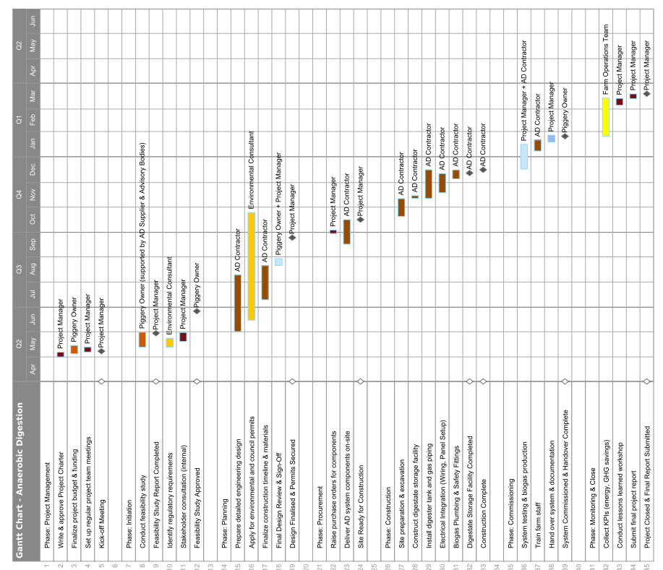

  - Stage Descriptions
The following stage descriptions provide more detail on the specific activities and deliverables within each phase of the above schedule.

Stage | Description | Activities | Deliverables
Initiation | Define the project foundation and confirm viability. | Draft Project Charter; conduct feasibility study; identify regulatory requirements; internal stakeholder consultation. | Project Charter, Feasibility Study Report, Stakeholder Register, Go/No-Go Decision.
Planning | Finalise all technical, financial, and regulatory details before execution. | Prepare detailed engineering design; apply for permits (EPA, council); consult funding partner; prepare procurement & construction plans. | Final Engineering Design Package, Approved Permits, Procurement Plan, Construction Timeline, Updated Risk Register.
Procurement | Procure and deliver necessary materials and equipment. | Raise purchase orders; coordinate delivery of digester, generator, biogas piping, storage tank; check site readiness. | Delivery Logs, Equipment Invoices, Site Ready for Construction Certificate.
Construction | Build the AD system, storage facility, and infrastructure. | Site prep and excavation; install tank digester; biogas plumbing and CHP generator; build digestate storage; electrical and safety fittings. | Constructed AD System, Completed Digestate Storage Unit, As-Built Drawings, Construction Completion Report.
Commissioning | Test system performance and handover to farm operations. | System testing (biogas production, flare, generator output); staff training; documentation handover; rectify defects if needed. | Commissioning Report, O&M Manual, Trained Farm Team, System Handover Certificate.
Monitoring & Closure | Verify outcomes and formally close the project. | Collect KPIs (GHG savings, digestate volume, revenue); conduct lessons learned workshop; finalize closure report. | Post-Commissioning Dashboard, Final Project Report, Project Closure Sign-Off, Lessons Learned Log.

  - Build Cycles
To support the delivery of each stage, structured build cycles and recurring project meetings are planned, as outlined below:
Ceremony |  | Purpose | Frequency
Project Kick-Off Meeting | Align all stakeholders and formally launch the project |  |  | Once (Start of Initiation Stage)
Design Review Workshop | Review, refine and approve the final AD and storage facility designs. |  |  | Twice (30% and 100% design stages)
Stage Gate Reviews | Approve transition from one phase to the next |  |  | At the end of each phase (e.g., planning → procurement)
Weekly Project Team Meetings | Ensure short-term progress is on track, address issues early. |  |  | Weekly throughout the entire project
Regulatory Check-in Sessions | Provide updates to EPA and council, clarify permit requirements. |  |  | At key compliance milestones
Commissioning Planning Meeting | Assign roles and ensure readiness before testing and handover. |  |  | Once (Pre-commissioning)
Lessons Learned Workshop | Capture successes and challenges to inform future projects. |  |  | Once (End of project)

  - Definition of Ready & Done
To ensure smooth delivery and shared understanding, each major work package in this project follows a clear Definition of Ready (DoR) and Definition of Done (DoD). The DoR sets the minimum conditions that must be met before work can begin, while the DoD confirms that all quality, safety, and performance requirements have been satisfied before a task is considered complete.
The Definition of Ready (DoR) is linked to the entry conditions described in Section 5.2—for example, construction work only begins once equipment is delivered and the site is ready.
The Definition of Done (DoD) aligns with the milestone approvals and review points in Section 5.3—for instance, phase transitions only happen after a Stage Gate Review confirms all deliverables are met.
This helps the project flow in a controlled sequence, with every stage starting and finishing based on clear, agreed conditions.

Work Package | Definition of Ready | Definition of Done | Approver(s)
Design Package | • Scope defined and drawings drafted  • EPA and council requirements reviewed  • Design team available | • All drawings approved  • Specs meet project goals  • Complies with EPA limits | QA & Safety Officer, Environmental Consultant
Procurement Plan | • Final design locked  • Bill of Materials confirmed  • Budget verified  • Supplier shortlists completed | • Equipment ordered  • Delivery timelines confirmed  • NAB Loan Officer signs off budget  • Risk log updated | Project Manager, NAB Loan Officer
Construction Work | • Site ready  • Equipment delivered  • Contractor team briefed and mobilised | • AD system and digestate storage built  • Weld and leak tests passed  • No major defects remaining | Site Supervisor, QA & Safety Officer
System Commissioning | • Equipment installed  • Utilities connected  • Staff ready for training  • Feedstock prepared | • ≥120 m³/day biogas, ≥60% CH₄ for 3 days  • Generator at ≥90% power  • Staff trained  • Handover documents completed | Commissioning Technician, Farm Ops Manager
Project Closure | • All data and reports collected  • Stakeholders scheduled for review | • Final report submitted  • KPIs reviewed  • Lessons logged  • Piggery owner signs off | Project Manager, Piggery Owner

5.5. Deployment
Deployment Strategy
The deployment process directly builds on the commissioning stage described in Section 5.2, where the system is tested and handed over to farm operations.
Each deployment step (dry commissioning, wet commissioning, ramp-up, and handover) follows the same Definition of Ready and Definition of Done principles from Section 5.4, ensuring the system is only handed over once performance and safety criteria are met.
Deployment activities are also supported by the Commissioning Planning Meeting listed in Section 5.3, which prepares all stakeholders for a smooth and accountable system rollout.
-Where Deployment Happens:
- On the farm – All main equipment (like the digester tank, generator, and digestate storage) is set up on-site.
- Monitoring system – A digital system will help check if everything is running smoothly and give alerts if there is a problem.
- Backup plan – If the generator is not ready on time, a flare unit will safely burn off the gas until full operations begin.
-How the System Will Be Rolled Out:
- Dry Commissioning – Check all parts (like valves, pumps, wiring) without adding waste.
- Wet Commissioning (Pilot Phase) – Add a small amount of manure and waste to test if the digester can produce biogas safely.
- Ramp-Up – Slowly increase the amount of waste until the system runs at full size.
- Handover – Train the farm staff, share important documents (manuals, SOPs), and give full control of the system to the farm team.
-Who Does What:
Task | Responsible Person | Final Approval By
Final tests and inspections | Commissioning Technician | QA Officer
Operator training and SOP review | AD Technology Supplier | Farm Operations Manager
Give over all documents/manuals | Project Manager | Piggery Owner
Provide help after handover | QA Officer | AD Technology Contractor/Supplier
After Deployment:
- The system will be checked weekly to make sure it is producing enough gas and treating waste properly.
- Each month, the team will review how it’s running and update SOPs if needed.
- A final report will be written after 6 months, summarising what worked well and what could be improved in future projects.

- Project Governance
This project adopts a hierarchical governance model aligned with the waterfall delivery method, ensuring clear responsibilities, structured communication, and effective issue escalation throughout each phase.

A formal Project Team Hierarchy (see Section 6.1) outlines leadership, delivery, and support roles. The Piggery Owner, as Project Sponsor, provides strategic oversight and authorisation, while the Project Manager centrally coordinates technical teams, regulatory bodies, and operations staff.

Operational personnel—including installers, consultants, and farm workers—are empowered to make domain-specific decisions but remain accountable to the Project Manager. This structure balances autonomy with oversight, supporting timely delivery, risk management, and regulatory compliance.

  - Project Team
The project team for the 535-sow anaerobic digestion (AD) system project has been structured to reflect both delivery responsibility and decision-making authority. The team includes key stakeholders who are directly involved in the day-to-day planning, installation, and commissioning of the AD system. A clear hierarchy ensures accountability, communication efficiency, and effective project control under a waterfall methodology.

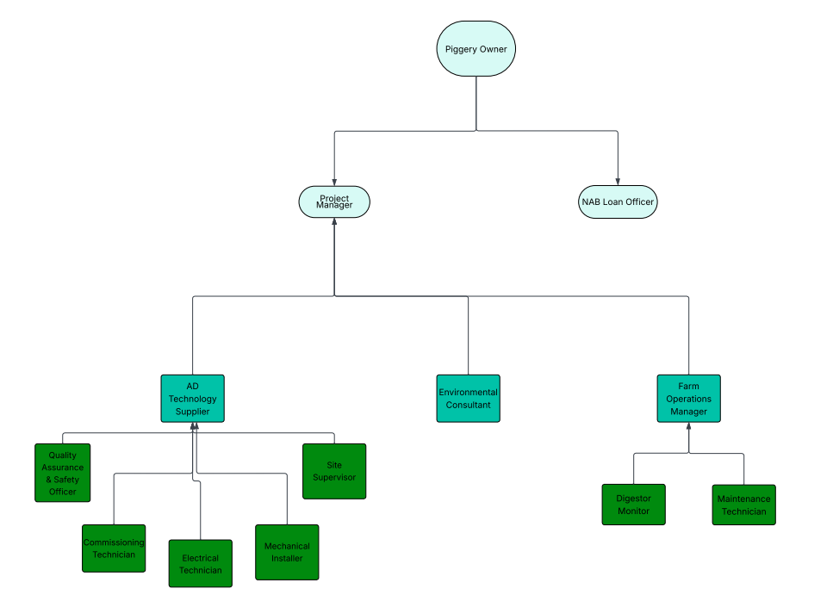

The following stakeholders are included in the hierarchy chart because they are actively responsible for core phases of delivery:
Strategic Oversight – Sponsor Level
Piggery Owner (Project Sponsor): Sets the project vision, approves budgets, and makes final calls.
Project Leadership – Management Level
Project Manager: Oversees day-to-day delivery, keeps everyone on track, and reports back to the Sponsor.
NAB Loan Officer: Manages funding releases and ensures milestone payments align with loan terms.
Delivery Team – Design, Build & Commission
Led by the AD Technology Supplier
Quality Assurance & Safety Officer
  - Checks that plans, welds, and tests meet quality and safety rules.
Site Supervisor
  - Runs on-site construction and installation work.
Mechanical Installer
  - Puts in pumps, pipelines, tanks, and moving parts.
Electrical Technician
  - Installs cables, control panels, sensors, and wiring.
Commissioning Technician
  - Starts up the system, runs performance tests, and hands over to operations.

Compliance & Environmental Oversight
Environmental Consultant
  - Ensures designs and operations follow EPA Victoria and local council rules, handles permits.

Operational Team – Post-Handover
Led by the Farm Operations Manager
Farm Operations Manager
  - Takes full ownership of the running system and leads the operations team.
Digestor Monitor
  - Checks digestate quality and records volumes for compliance and reporting.
Maintenance Technician
  - Keeps all pumps, valves, and equipment working smoothly with routine servicing.

Why Not All Stakeholders Are Included in the Hierarchy
While all stakeholders play a role in project success, not all are included in the project team hierarchy chart for the following reasons:
Stakeholder | Reason for Exclusion
Third-Party Digestate Buyer | Commercial partner—not involved in internal project delivery. Their role is governed by a procurement/offtake agreement.
EPA Victoria & Local Council | Regulatory authorities. They issue permits and provide oversight but are not part of internal operations or delivery.
Industry Advisors | Provide strategic input and sector guidance but do not manage or execute deliverables.
Local Community | External, low-power/low-interest stakeholders who are kept informed but not involved in execution.
Roles and responsibilities described here directly map to the project’s key deliverables and stage activities detailed in Section 5. This alignment ensures structured accountability and traceable delivery outcomes, further reinforced by the RACI matrix in Section 4.

  - Decision Management
The project will follow a hierarchical decision-making structure, ensuring that critical decisions are approved by stakeholders with the appropriate authority while operational decisions are delegated to relevant specialists. This approach supports accountability, traceability, and timely escalation when required.
Decision Type | Decision-Maker(s) | Escalation Path | Approval Required
Strategic Decisions  (e.g. scope changes, major budget reallocations, contractor disputes) | Piggery Owner | N/A | Required from Piggery Owner
Project Execution & Coordination  (e.g. scheduling, procurement priorities, stakeholder engagement) | Project Manager | Piggery Owner (if out of scope or budget) | Reviewed with Piggery Owner
Technical & Installation Decisions  (e.g. design clarifications, equipment substitutions, layout adjustments) | AD Technology Supplier | Project Manager | Inform Project Manager
Environmental Compliance  (e.g. permitting queries, EPA feedback, design-alignment with regulations) | Environmental Consultant | Project Manager | May require EPA sign-off
Operational Readiness  (e.g. handover, training, commissioning adjustments) | Farm Operations Team & Project Manager | Piggery Owner (if timeline shift) | Yes, at commissioning stage

- Project Budget
The budget is structured into four main categories: Labour, Equipment, Materials, and Operational/Other Costs. It includes all key project components such as the digester unit, biogas generator, gas handling system, construction works, and commissioning activities.

All costs are presented in Australian Dollars (AUD) and reflect estimated market prices as of 2025. Labour costs are based on estimated hours required for each role across all project phases, while equipment and materials are priced based on recent supplier quotes, industry benchmarks, and comparable project case studies.

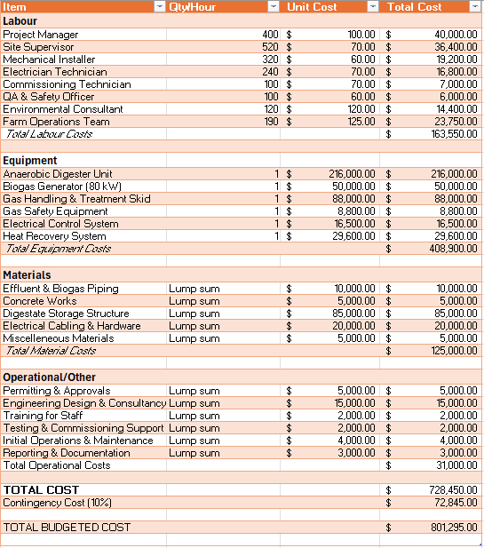

7.1 Cost Assumptions
- Labour rates are based on industry-standard hourly wages in regional Victoria, including contractor margins and overheads.
- All equipment costs assume purchase of new components, not second-hand units, to ensure reliability and supplier warranties.
- Piping and cabling costs are based on average lump-sum pricing for mid-sized installations.
- The biogas generator is budgeted as an 80 kW CHP unit, aligned with on-site electricity demands and energy offset goals.
- A covered lagoon-type digester is assumed, including earthworks and impermeable HDPE lining.
- Environmental permitting and gas safety compliance costs reflect local council and EPA Victoria application fees.
- A 10% contingency is applied to the subtotal project cost to cover design adjustments, material price fluctuations, or minor scope changes.
- Project Management Controls
  - Risk Management
To stay on track and limit surprises, we follow a three-step risk process. First, we assess each risk by scoring its probability (1–5) and impact (1–5), then multiply them to get a Risk Priority Number (RPN = P×I). We interpret the RPN to prioritise our focus: low-risk items (RPN ≤ 7) are reviewed quarterly, medium-risk (8–14) bi-weekly, and high-risk (≥ 15) weekly or immediately addressed. Next, we plan by setting exact triggers that launch mitigation actions and fallback contingencies. Finally, we monitor all risks continuously, reviewing higher-RPN items more frequently. The table below shows our top risks, their scores, owners, and responses.
Category | Risk / Opportunity | Prob.  (1–5) | Impact (1–5) | RPN | Owner | Mitigation | Trigger | Contingency | Review
Strategic (5–10 yr) | ↓ Gov’t support for biogas | 3 | 4 | 12 | Piggery Owner | Monitor policy; diversify to heat & power sales | New draft policy removing biogas incentives | Shift to digestate-only revenue model | Biannual with Sponsor & PM
 | ↑ New carbon-credit grants | 4 | 3 | 12 | Environmental Lead | Register for credits; apply to grants when announced | Official grant guidelines published | Reinvest extra revenue into farm sustainability capex | Biannual with Sponsor & PM
Investment (3–5 yr) | ↓ Buyer cancels digestate off-take | 2 | 5 | 10 | AD Supplier/Contractor | Add fallback clause; explore farm reuse and local buyers | Notice of contract termination | Build on-site storage buffer for 3 months | Quarterly contract & yield review
 | ↑ Biogas exceeds design | 3 | 4 | 12 | Operations Manager | Monitor yield; plan for heat recovery or export grid feed-in | Sustained yields >110 % of design for 2 months | Fast-track CHP upgrade to absorb surplus | Quarterly performance review
Project (1–3 yr) | ↓ Gen-set delivery delayed | 4 | 4 | 16 | AD Supplier/Contractor | Order 3 months early; include delivery penalties in PO | No delivery confirmation by scheduled date | Rent a backup gen-set; negotiate expedited shipping | Fortnightly during construction
 | ↑ Early installation finish | 2 | 3 | 6 | AD Supplie/Contractor | Mobilise commissioning team in advance; offer contractor bonus | Site sign-off 2 weeks before planned date | Begin partial commissioning on completed areas | Fortnightly during construction
 | ↓ Inadequate staff training | 3 | 3 | 9 | QA & Safety Officer | Deliver hands-on SOP workshops; provide quick-start guides | First-week error reports >5 % of operations logs | Bring in external trainer; extend on-site support | Weekly until stable operation

  - Quality Management
To ensure our anaerobic digestion (AD) system reliably produces biogas, treats waste safely, and meets EPA Victoria regulations, we apply a four-pillar Quality Management framework: Planning, Assurance, Control, and Tools & Techniques.
Quality Planning: Define “what good looks like” and who owns it.
- Objectives:
  - Biogas Yield: ≥ 120 m³/day, CH₄ ≥ 60 %. (Ensures the digester produces enough gas to meet our energy goals.)
  - Waste Treatment: COD removal ≥ 70 %, VS destruction ≥ 80 %. (Measures how effectively the system breaks down organic material)
  - Emissions: Fugitive CH₄ and H₂S under SEPP (Air Quality) limits. (Controls unintended gas leaks.)
  - Digestate Safety: Pathogen < 100 cfu/g, salts within EPA “low-risk” thresholds. (Guarantees the leftover material is safe for land application.)
- Standards & Compliance:
  - EPA Vic: SEPP (Air Quality), SEPP (Waters), and Waste-to-Land Guidelines.
  - Industry: ISO 9001 principles and AS/NZS 8405 procurement rules.
- Roles & Responsibilities:
Activity | Responsible | Accountable
Define objectives & metrics | QA & Safety Officer | Project Manager
Document standards & SOPs | QA & Safety Officer | Project Manager
Configure monitoring systems | AD Technology Supplier/Contractor | QA & Safety Officer
Approve EPA compliance reports | Environmental Consultant | Piggery Owner

Quality Assurance (QA): Prevent defects through audits, reviews, and improvements.
- Design Audits: Design reviews at 30 % and 100 % completion—check drawings, specs, and vendor info against EPA rules.
- Supplier Qualification: Require ISO 9001 factory QA certification and test certificates for digesters, CHP units, and scrubbers.
- Pilot Trials & PDCA:
  - Plan: Set feed ratios in a small lagoon trial.
  - Do: Run a two-week test, log biogas and effluent data.
  - Check: Compare results to objectives and EPA criteria.
  - Act: Update SOPs and design parameters before full-scale build.
- Continuous Improvement Workshops: Lean Six Sigma (DMAIC) sessions mid-project and pre-commissioning to reduce waste (e.g., feedstock spoilage) and optimize retention.
- Training & Documentation: SOP training for operators on feeding, sampling, and safety.

Quality Control (QC): Detect and correct defects via inspections, testing, and monitoring.
- Inspections & Tests:
Item | Activity | Criteria
Digester Welds | Visual + radiographic inspection | Zero critical defects
Piping & Valves | 1.5× design pressure leak test | No pressure loss over 24 h
CHP Unit | Factory witness performance test | ≥ 90 % rated power
Digestate Sampling | Send digestate samples to an accredited lab for analysis of salt concentrations and pathogen counts. | Within EPA “low-risk” limits
- KPI Monitoring:
  - Review deviations in key metrics—daily biogas flow, methane content, COD removal rate, and digestate quality—each morning during commissioning stand-ups and again in the weekly project progress meeting.
- Corrective Actions:
  - Log non-conformances.
  - Analyse root cause with “5 Whys.”
  - Implement fixes (e.g., adjust feed rates, repair valves).
  - Verify effectiveness and update SOPs to prevent recurrence.

Tools & Techniques: Embed best-practice methods across phases.
To keep things simple and effective, we focus on three core methods that fit our AD project’s scale and needs:
- PDCA (Plan-Do-Check-Act):
  - Plan: Define trial feed mixes and test procedures in a small lagoon.
  - Do: Run the pilot, record biogas rates and effluent data.
  - Check: Compare results to our targets (≥120 m³/day, ≥60 % CH₄).
  - Act: Update SOPs and adjust design before full-scale build.
- FMEA (Failure Mode & Effects Analysis):
  - Gather the QA Officer, Site Supervisor, and Commissioning Tech to list the top 5–10 ways the system could fail (e.g., pump clogs, gas leaks).
  - Score each by severity and likelihood, then add simple safeguards (alarms, spare parts) for the highest-risk items.
- Process Mapping:
  - Draw a step-by-step flowchart from manure intake → digestion → gas cleanup → energy output → digestate reuse.
  - Mark each QA/QC checkpoint on the map (e.g., weld test, pressure test, lab sample) so everyone knows exactly when and where tests occur.

  - Project Tools
Tool | Purpose
Google Docs, Microsoft OneDrive, SharePoint | Used for preparing and sharing project documents, risk registers, and stakeholder communication plans.
Microsoft Teams, Zoom, Email | Used for regular team meetings, updates, risk review discussions, and client reporting.
LucidChart | Support technical diagrams, layout plans, and visual presentation of project data.
Microsoft Excel, Google Sheets | Create the project budget, track expenses, and forecast cost performance.
SmartSheet | Create timelines (like your Gantt chart), assign tasks, monitor progress, and ensure deadlines are met.

Reference List
Australian Pork Ltd. (2020, May 1). Viability of biogas on medium-scale piggeries. https://australianpork.com.au/viability-biogas-medium-scale-piggeries
Environment Protection Authority Victoria. (2024, February 15). Safe production and use of digestate: Guidelines for the application of waste to land. https://www.epa.vic.gov.au/for-business/waste/waste-duties/safe-production-and-use-of-digestate-guidelines
Evo Energy Technologies. (n.d.). Kia Ora Piggery’s biogas cogeneration project. Retrieved May 12, 2025, from https://www.evoet.com.au/projects/kia-ora-piggery/
Fluence. (n.d.). Anaerobic digestion. Retrieved May 12, 2025, from https://www.fluencecorp.com/anaerobic-digestion/
Intergovernmental Panel on Climate Change. (n.d.). Climate change 2021: The physical science basis: Chapter 7: The Earth’s Energy Budget, Climate Feedbacks, and Climate Sensitivity. Retrieved May 12, 2025, from https://www.ipcc.ch/report/ar6/wg1/chapter/chapter-7/
Skerman, A., & Collman, G. (2012). Methane recovery and use at the Grantham piggery: A case study (RIRDC Publication No. 12/064). Rural Industries Research and Development Corporation. https://era.dpi.qld.gov.au/id/eprint/2331/1/RIRDC_FinalReport12-064_Skerman.pdf

APPENDIX

Work breakdown of the report
Section | Person(s) completed
Improvements | Saad - 21186351
Deliverables – Roles and Responsibilities | Manav - 21684505
Deliverables – Description | Manav - 21684505
Plan – Schedule and Delivery | Amal & Manav
Plan – Stage Descriptions | Amal - 21593857
Plan – Build Cycles | Amal - 21593857
Plan – Definition of Ready & Done | Amal & Manav
Plan – Deployment | Krishna & Saad
Governance – Project team | Krishna & Saad
Governance – Decision management | Krishna - 21155712
Budget | Krishna - 21155712
Controls – Risk management | Ali – 21832880
Controls – Quality management | Ali - 21832880
Controls – Project tools | Ali - 21832880

Team Charter

1. Overview
This document sets out the way your team should work together to complete the remainder of the NAB project (assessment 2 and 3). Consider the charter as a living, breathing, dynamic and reflective document that should be reviewed and updated as your views and working arrangements evolve. Make sure that each team member retains a copy of the charter. This charter should be submitted as an appendix to the report in both Assessment 2 and 3.

Through this process you will be better able to:

- Delegate roles and responsibilities.
- Plan and manage time.
- Share diverse perspectives.
- Refine understanding through discussion and explanation.
- Pool knowledge and skills.
- Hold one another (and be held) accountable.
- Develop new approaches to resolving differences.
- Establish a shared identity with other group members.

And these learnings will place you better to add value through teamwork once you enter the workforce.

Team name:
EcoGen Solutions

Team member names:
ID Number | Full Name
21186351 | Syed Saad
21684505 | Manav Nursmooloo
21832880 | Ali Imran
21155712 | Krishna Gulati
21593857 | Amal Kapadia

Team goals
Team goals | Measure of success
Example 1: Distinction for project  Example 2: Completion of all assessment tasks on time | Example 1: Achieving a score of 75% + for Assessment Task Example 2: Clearly articulated milestones with roles and responsibilities and regular team meetings
Attendance to all meetings. | All members attend at least 90% of meetings; absence is notified in advance
Even distribution of work done | Each team member is responsible for at least one key deliverable; all contributions are tracked using a shared task log; team confirms balance in a mid-project check-in
Completion of work to a high standard | Drafts undergo at least one round of peer feedback; all final submissions are proofread and aligned with rubric

Team SWOT
Team member | Strengths | Weaknesses | Ideal / preferred role / contribution
Syed Saad | Strong understanding of scope, objectives, and project framing; structured thinker | May over-focus on structure and under-prioritise visual design or creative elements | Presentation lead
Manav Nursmooloo | Clear communicator, excels at breaking down tasks and clarifying responsibilities | Tends to spend extra time perfecting wording, which may delay submissions | Document structure & editing lead
Krishna Gulati | Analytical, good with numbers and finance logic; aware of accountability chains | Can sometimes get caught up in details and overlook broader context | Governance & Budget Lead — handles cost model and sign-off structure
Ali Imran | Big-picture thinker, risk-aware, good at lessons-learned and project wrap-up | May lose focus on small deliverables or daily task progress | Risk & Wrap-Up Lead — ensures risk plan is solid and the project closes cleanly
Amal Kapadia | Timeline-focused, good with tools like Gantt charts and milestone planning | Can be rigid with deadlines, sometimes underestimating team workload pressures | Schedule & Execution Lead — owns the “when and how” of the project

Team milestones

Task | In-charge | Due date
Team Charter | Manav | 03/05/2025
Research Phase | Syed & Krishna | 01/05/2025
Writing | Syed & Amal | 08/05/2025
Editing | Manav | 09/05/2025
Prototype design | Amal & Ali | 04/05/2025
Submission of report | Manav | 09/05/2025
Preparation of Presentation | Krishna & Ali | 20/05/2025

Note: This is a significant clause in your charter, so make sure your team gives it lots of thought. You should avoid simply allocating big chunks of the assessments to each team member, it is preferable that all team members have a role in each aspect of each assessment task or at a minimum in the editing of each of the submissions.

Team meetings
The team will meet to discuss the progress of the project on the following dates:
Meeting Agenda | Date / time / how
Kickoff and task assignment | Week 7 – On campus
Progress review – Research Phase | Week 7 – Group Chat
Draft review & editing sync | Week 9 – Google Docs
Final check before submission | Week 9 – Zoom Call
Presentation dry-run | Week 11 – On Campus

Agreed team behaviours

The team agrees to abide by the following guidelines for team conduct (this should include how conflicts will be resolved and expectations around timelines/milestones i.e. what happens if someone doesn’t deliver on time?): and expectations around timelines/milestones i.e. what happens if someone doesn’t deliver on time?):

Behaviour | Plan of action
Example: We agree to not be ‘free-riders’ in our own team | If someone misses a task twice without reason, a group meeting will be held to reassign and report issue if unresolved.
Respect meeting times | Arrive on time or notify group 12+ hours in advance.
Meet deadlines | Tasks must be submitted to the group at least 24 hours before shared deadlines for team review.
Encourage open feedback | Comments welcome in all shared drafts and group chats—no judgement.

Team member sign off
Sign off is required after the initial completion of the team charter.
Team member | Sign off
Manav Nursmooloo | 30/05/2025
Krishna Gulati | 30/05/2025
Syed Saad | 30/05/2025
Amal Kapadia | 30/05/2025
Ali Imran | 30/05/2025

